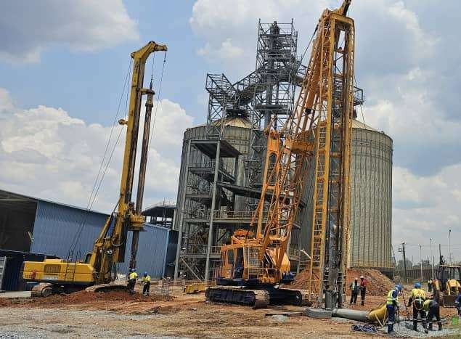



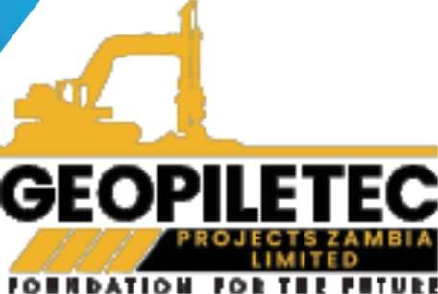



COMPANY PROFILE 2025


CONTENTS

ABOUT US OUR VISION OUR MISSION
......................... 03

QUALITY ASSURANCE STATEMENT 04
WHY CHOOSE US

CORE VALUES OBJECTIVES
SAFETY POLICY CODE OF ETHICS
........................ 05
......................... 06

OUR TEAM
COMPANY DIRECTORS COMPANY STRUCTURE
................ 07
................ 08

PRODUCTS & SERVICES ................
09-13

MESSAGE FROM DIRECTORS

COMPANY DETAILS
................ 14

ATTACHMENTS
...........................
15-22

COMPANY PROFILE

ABOUT US

GEOPILETEC PROJECTS ZAMBIA LIMITED was established and incorporated as a private limited company by shares in 2022 in Kitwe, on the Copperbelt Province Zambia. It is a Zambian owned company registered PACRA.
GEOPILETEC PROJECTS ZAMBIA LIMITED was founded on a commitment to performing projects within budget and according to specifications. The company was established on integrity in the delivery of services in civil engineering, construction, and general dealings beyond expectations.
Although a recently registered company, the directors have vast experience of construction works, and together with our qualified and experienced employees, we are well positioned to provide top quality construction and project management services. We take pride in delivering successful projects on time, within budget and to the highest quality standards.
Our team embraces safe work practices and procedures to ensure accident free working environment. We say; Safety Comes first. Arrive Safe, Work Safe and Go Home Safe.

OUR VISION
To be Zambia's leading construction partner, recognized for excellence, reliability, and innovation in delivering high-quality projects on time and within budget, consistently exceeding client expectation

OUR MISSION
To complete every project successfully to the client's expectations, always striving for quality within budget and on time

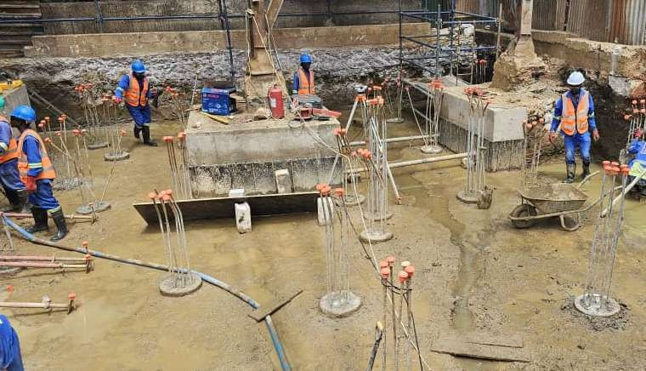



COMPANY PROFILE

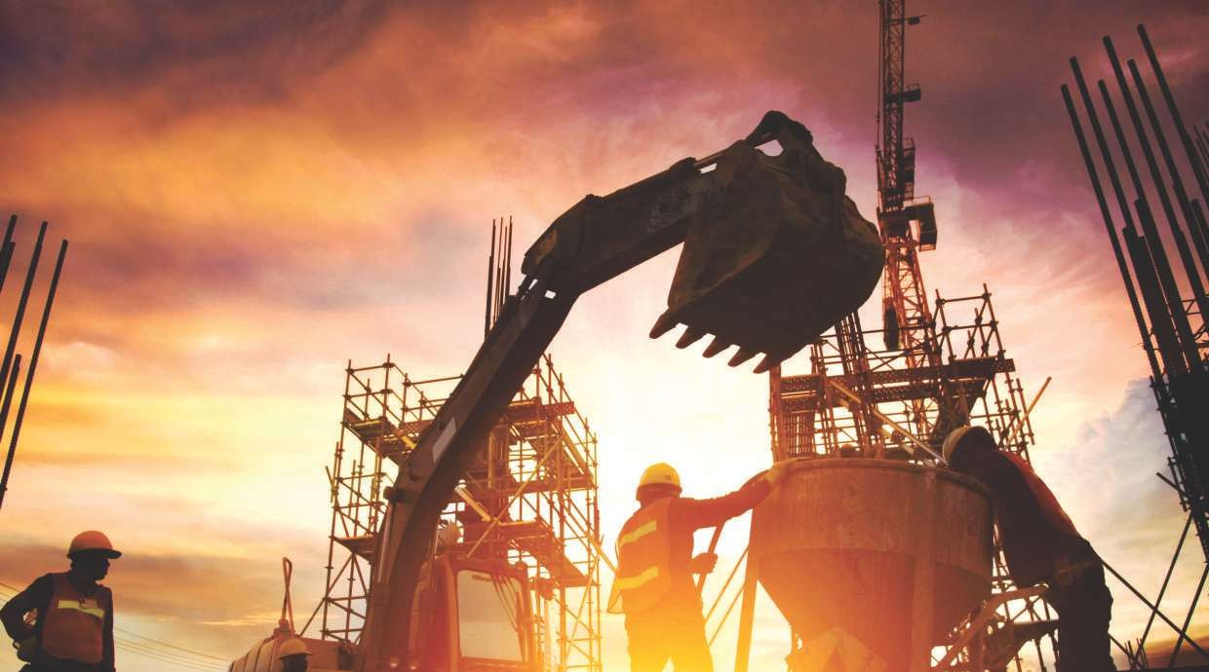

COMPANY PROFILE


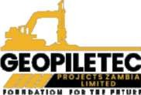
QUALITY ASSURANCE STATEMENT
GEOPILETEC PROJECTS ZAMBIA LIMITED is committed to maintaining the highest standards of quality in every project. Through rigorous planning, skilled craftsmanship, and continuous process improvement, we ensure that all work meets industry standards and exceeds client expectations. Our team follows structured quality control procedures at each phase, from design to completion, and actively seeks innovative solutions to deliver durable, efficient, and sustainable construction outcomes. By prioritizing quality in materials, methods, and performance, we pledge to provide reliable, long-lasting results on every project.

WHY CHOOSE US

Commitment to Quality: We prioritize excellence in every project, adhering to strict quality standards to ensure durable, reliable, and high-quality outcomes.
Timely Project Delivery: With a focus on efficiency and meticulous planning, we deliver projects on time, meeting or exceeding client expectations without compromising quality.

Experienced and Skilled Team: Our team of dedicated professionals brings extensive experience and expertise to each project, ensuring exceptional results at every stage of construction.

Local Experience: As a Zambian-owned company, we are deeply familiar with local requirements and standards, allowing us to provide relevant, compliant, and impactful solutions in Zambia’s construction sector.
Client-Centered Approach: We understand the unique needs of each client and tailor our solutions to meet specific project requirements, delivering satisfacton through transparency, communication, and flexibility.

CORE VALUES

Integrity

We conduct our business with honesty and transparency, building trust with clients, partners, and our community by upholding the highest ethical standards.

Quality Excellence



We are committed to delivering superior quality in every project, ensuring that all work meets or exceeds industry standards and client expectations.
Reliability
We keep our promises
and strive to meet all deadlines, delivering projects on time and within budget, consistently achieving dependable results.
Client Satisfaction
We prioritize our
clients’ needs, working closely with them to understand their vision and deliver solutions that fulfill their expectations
and add value.

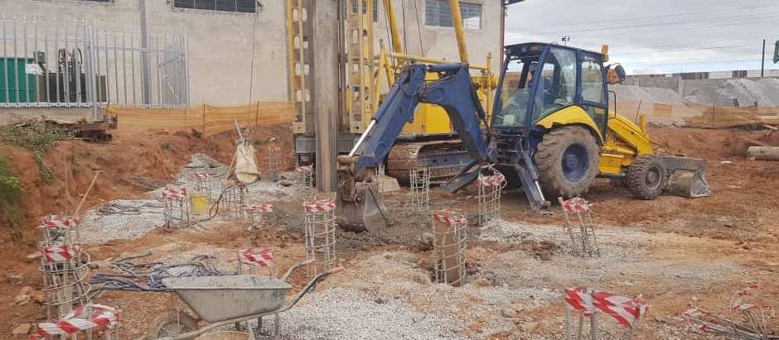




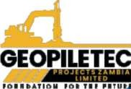

OBJECTIVES
Deliver High-Quality Projects: To consistently meet and exceed industry quality standards in every project, ens- uring client satisfaction and durable results.

Achieve Timely Completion:To complete all projects within the agreed-upon time frame, minimizing delays and maximizing efficiency through effective project management and planning.

Enhance Client Relationships: To regularly assess and improve our processes, embracing new techniques and technology that enhance the quality, efficiency, and sustainability of our work.

Foster Continuous Improvement: To regularly assess and improve our processes, embracing new techniques and technologies that enhance the quality, efficiency, and sustainability of our work.

COMPANY PROFILE

SAFETY POLICY
Conducting morning safety talk at the site office

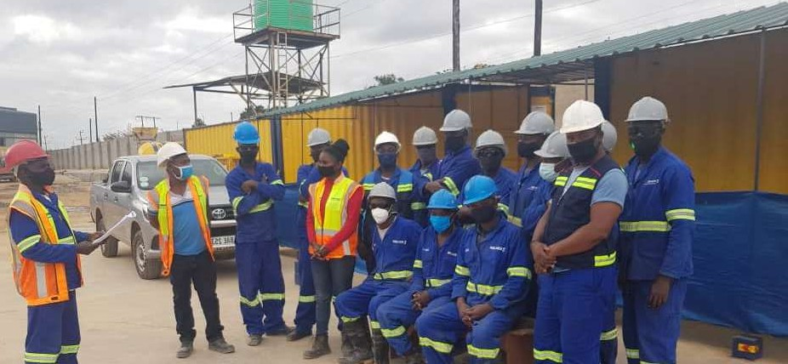


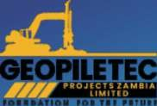
GEOPILETEC PROJECTS ZAMBIA LIMITED is dedicated to maintaining a safe and healthy work environment for all employees, clients, and partners. Our commitment to safety is integral to our operations, and we strive to eliminate or minimize any hazards associated with our construction activities. To achieve this, we adhere to the following principles:
Compliance with Safety Standards: We strictly follow all national safety regulations and industry standards, ensuring our practices are aligned with legal requirements and best practices in construction safety

Employee Training and Awareness: We provide regular safety training and resources to all team members, equipping them with the knowledge and skills needed to identify, report, and respond to potential hazards on-site.

CODE OF ETHICS
Continuous Improvement: We encourage a culture of learning, innovation, and continuous improvement, alwa- ys seeking ways to enhance our skills, processes, and impact.
Environmental Responsibility: We commit to sustainable construction practices, minimizing environmental impact and promoting responsible resource use to contribute positively to our community and environment.
Fairness and Respect: We treat all individuals clients, employees, suppliers, and community members with fairness, respect, and dignity, fostering a positive and inclusive environment.

Integrity and Honesty: We conduct all business with honesty and transparency, ensuring that our actions and decisions are ethically sound and aligned with our core values.
Compliance with Laws and Regulations: We adhere to all applicable laws, industry standards, and regulatory requirements, maintaining compliance and promoting ethical practices within the construction industry.

COMPANY PROFILE

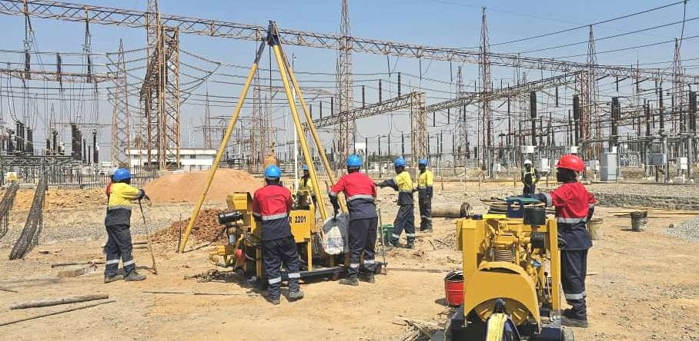


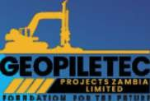
OUR TEAM

At GEOPILETEC PROJECTS ZAMBIA LIMITED, our team is our greatest asset. Comprising skilled professionals with extensive expertise in construction, engineering, project management, and safety compliance, our team is dedicated to delivering outstanding results on every project. We believe in fostering a collaborative, innovative, and safety-conscious work environment, where each member’s contribution is valued.

We believe in continuous development, providing regular training and growth opportunities that allow our staff to stay current with industry advancements and best practices. Our team operates with integrity, innovation, and a client-centered approach, making GEOPILETEC PROJECTS ZAMBIA LIMITED a trusted partner for construction projects in Zambia. We are proud of our team’s collective commitment to quality, safety, and reliability, which drives our mission to exceed client expectations in every project.

KEY CONTACT PERSONS
Gorden Gachata- CEO : +260 966 601 707
info@geopiletec.com gorden.gachata@geopiletec.com
Jeff Phiri - Director Projects
Angela Mweene - Director Commercial Services
COMPANY PROFILE




COMPANY STRUCTURE

BOARD OF DIRECTORS

CHIEF EXECUTIVE OFFICER

DIRECTOR- OPERATIONS
PROJECTS
DIRECTOR- COMMERCIAL SERVICES

DIRECTOR-

CONSTRUCTION ENGINEERING

TECHNICAL/ SALES ENGINEER

PROJECTS / DESIGN ENGINEER

COMPANY PROFILE



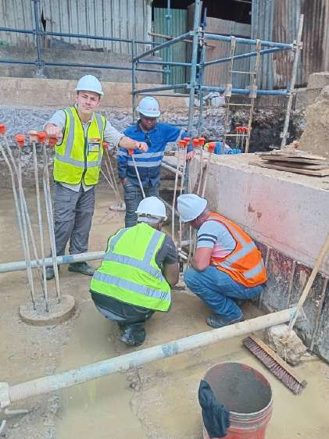
GALLERY

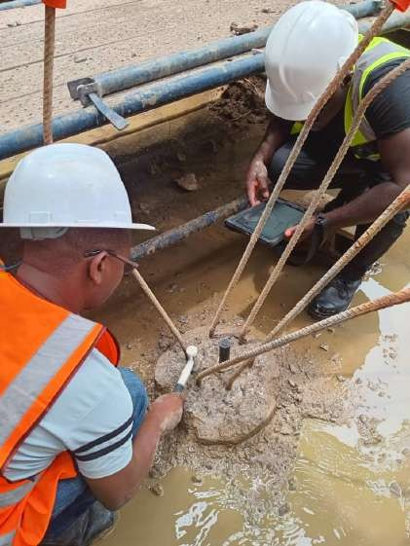
Pile Intergrity Test - PET
Conducting Pile Intergrity Test with Client
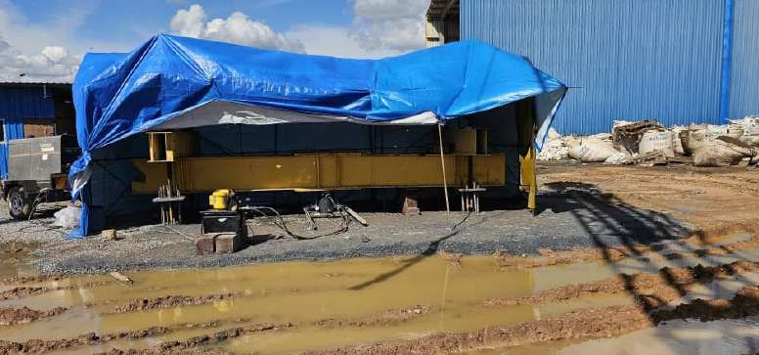
Test Pile - Setup on Site

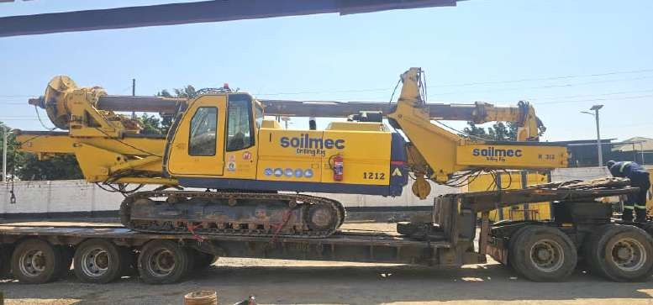
Soilmec - Drilling Rig

COMPANY PROFILE

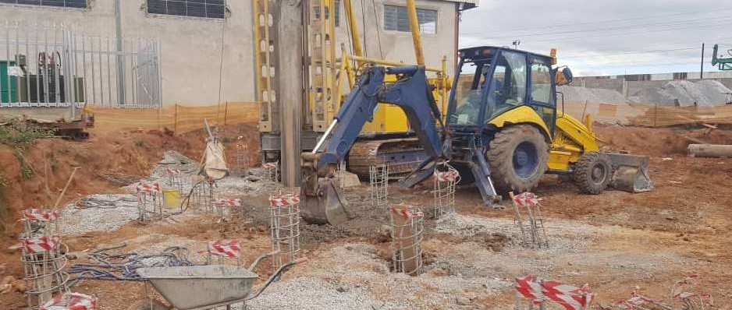

GALLERY

Site operations

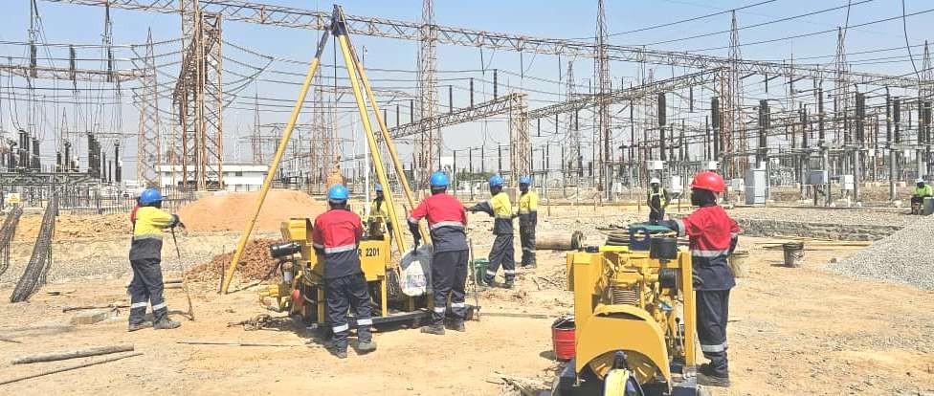
Piling Works in progress

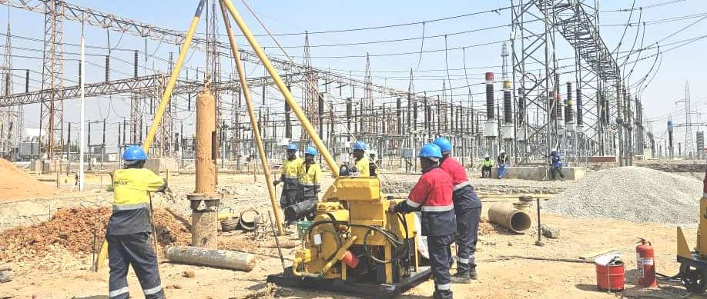
Coring during Piling - Percussion Bored Piles

COMPANY PROFILE

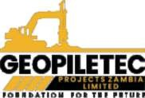
SERVICES

These services highlight GEOPILETEC PROJECTS ZAMBIA LIMITED dedication to delivering comprehensive, quality-focused solutions for a wide range of construction on and civil engineering projects.

Building Construction Piling works
Reinforced concrete construction Construction project Management Building Maintenance Services General trading.

Building Construction Civil Engineering
We deliver comprehensive building and civil engineering solutions, ensuring that each project meets the highest standards of quality, safety, and eﬃciency.

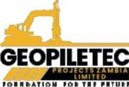
SERVICES

Piling works
We specialize in piling works, providing strong, stable foundations that are essential for safe and durable structures. Our expertise in various piling techniques ensures that projects are completed with precision and reliability.
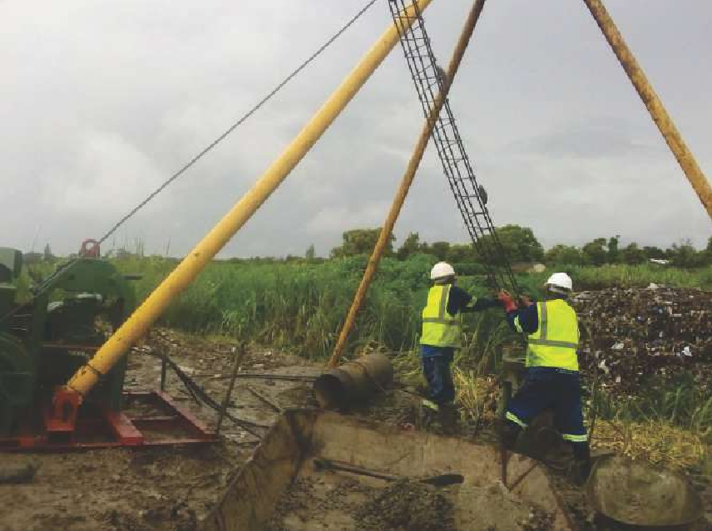
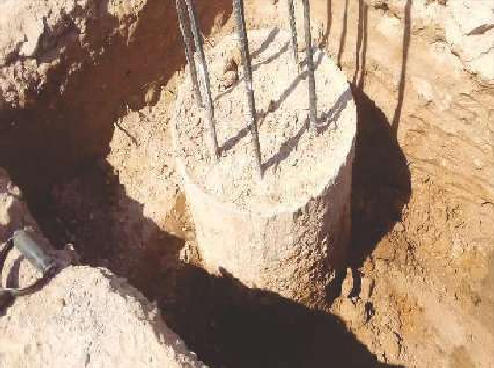

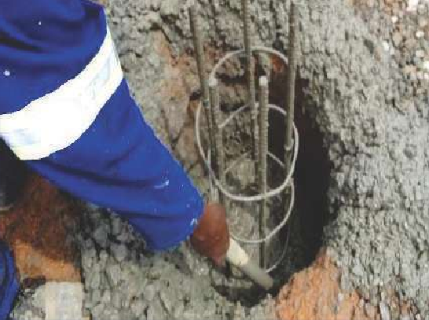
Reinforced Concrete Construction

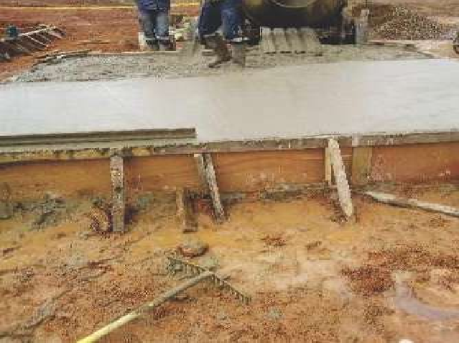
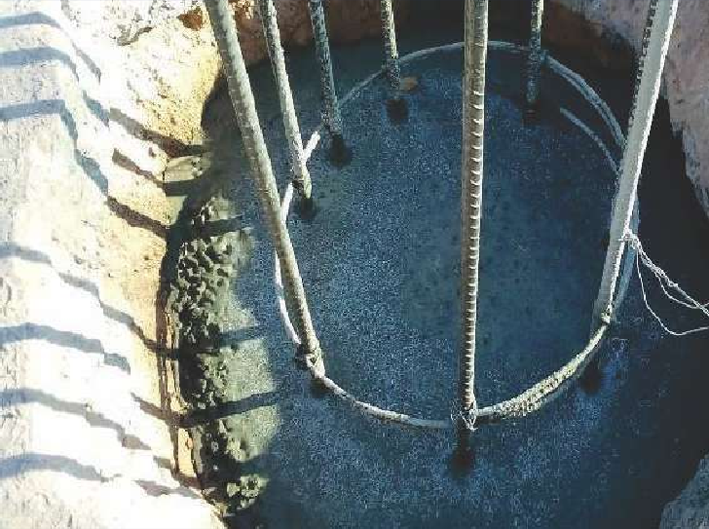
We provide expert services in reinforced concrete construction, a crucial aspect of modern building projects. Our experience ensures that reinforced structures are built to last, meeting all safety and strength requirements.


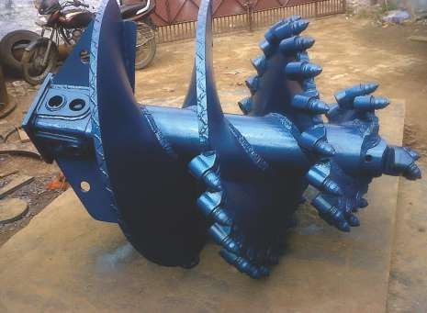
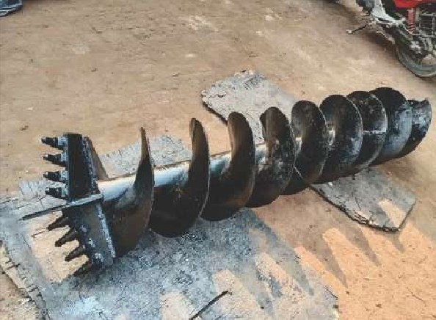
Pile diameters ranges from 300 mm diameter to 2000 mm diameter. The following sizes are the most common:
300, 350, 400, 450, 500, 600, 750, 900, 1050, 1200, 1350, 1500, 1650,1800 and 2000mm. Any other size within
this range is possible, but a special flight auger may have to be manufactured for any non-standard size.
COMPANY PROFILE

PROJECTS COMPLETED
Our major service offered is PILING works. We have vast experience in PILING and Construction works stretching for 21 years attained on various projects while working with leading international geo-technical and civil engineering organisations like DURA SOLETANCHY BACHY and FRANKIPILE INTERNATIONAL PROJECTS.

Key Note Projects managed and executed:
- Piling works for KCM Smelter plant
- Piling works for KCM Concentrator & KDP projects
- Piling works for Mopani Nkana Leach and Cobalt plants
- Piling works for Mopani Mufulira and Midola Deep Sha
- Piling works for National Milling – Lilayi
- Piling works for ECL Mall- kitwe
- Piling works for Mopani Nkana Concentrator
- Piling works for Maina Soko Military hospital
- Piling works for Chipata Petroleum Depot
- Jet grout projects for Barrick Lumwana mine & Lubambe Nkonkola mine
Note: A lot of experience was gained from several major to medium projects executed locally and outside Zambia in the following countries:
-Tanzania
-Mauritius
-Uganda
-Mozambique
-Zimbabwe
-South Africa
-Malawi

PILING PRODUCTS WE ARE CURRENTLY OFFERING:

• Open Hole Auger Piles:

• Forum Bored Piles:

•Franki Driven Piles:

Construction Project Management
We specialize in piling works, providing strong, stable foundations that are essential for safe and durable structures. Our expertise in various piling techniques ensures that projects are completed with precision and reliability.
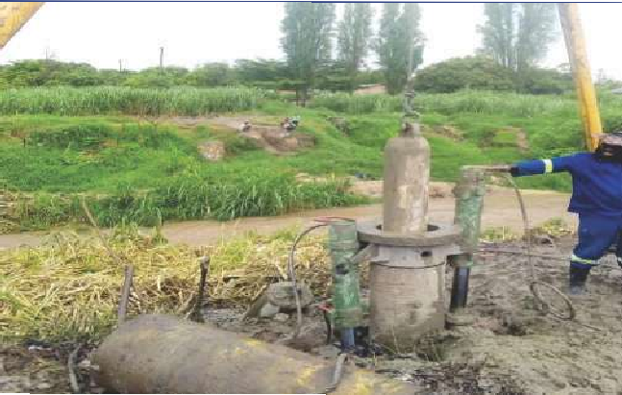
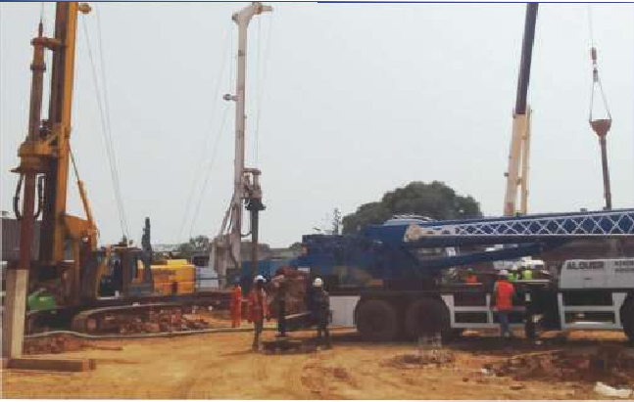

Percussion/ Forum Bored Piles:
This piling system is more suitable for contracts with low headroom and /or limited or difficult access. It consists of relatively small and light piling equipment assembled on a tripod and a winch.
-The pile nominal size is 410 mm diameter. The typical working load (Kn) is 500-800 Kn.
-The enlarged base formed at the toe of the pile has an added advantage to carry heavy loads.
-Maximum depth is 12.0m but depending on the soil conditions greater depths are possible.

Franki Driven Cast -in –situ Piles
This is the most commonly and extensively used pile type in Southern Africa. With the wide range of pile sizes from 410 mm to 610 mm diameter and the advantages of the enlarged base formed at the toe of the pile, the Franki pile is suited to structures that vary from single storey to multi-storey office blocks.
-The typical working load ranges from 700 Kn to 2000Kn
-Maximum depth is 12.0m
Note: With our vast experience in piling systems, we have the capacity to handle small, medium and large





MESSAGE FROM DIRECTORS

At GEOPILETEC PROJECTS ZAMBIA LIMITED, our journey began with a vision: to become a trusted partner in the construction industry, known for delivering high-quality projects that meet and exceed our clients' expectations. Since our establishment, we have remained committed to our core principles of integrity, quality, safety, and client satisfaction.

We understand that the success of any construction project lies in the details, meticulous planning, skilled execution, and unwavering commitment to timelines and budgets. This dedication to excellence has earned us the trust of our clients and partners and strengthened our reputation as a reliable and innovative construction company.

Thank you for placing your trust in GEOPILETEC PROJECTS ZAMBIA LIMITED. We look forward to partnering with you to bring your vision to life and contribute to building a better future.

Warm regards, The Directors
GEOPILETEC PROJECTS ZAMBIA LIMITED

COMPANY DETAILS
Legal Name: GEOPILETEC PROJECTS ZAMBIA LIMITED
TPIN: 2003185277
Company Reg No.: 120241008252
Physical Address Old Coca-Cola Building Corner of Langesha & Nyerere Roads Kitwe

